The Digestion of White Bread

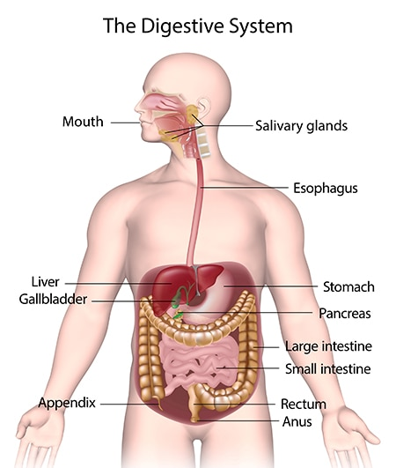

<https://www.niddk.nih.gov/health-information/digestive-diseases/digestive-system-how-it-works>

## Mouth and Oesophagus

The bread enters the mouth where digestion begins. The grinding actions of the teeth when chewing begins mechanical digestion, physically breaking down the bread into smaller more manageable particles for the body to digest. Saliva is secreted by the salivary glands in the back of the mouth, which contains enzymes, primarily amylase. Amylase breaks down starches and complex carbohydrates in the bread into simple sugars (glucose mainly) that your body can absorb easily.

Once thoroughly chewed, the mixture of food and saliva, having formed a ball called a bolus, passes through the pharynx into the oesophagus. The epiglottis: a flap or ‘lid’ made of cartilage, covers the larynx when swallowing to prevent the bolus from entering the trachea. The oesophagus, a muscular tube that connects the mouth to the stomach, contracts in wave-like motions and squeezes the bolus down the length of its tract, this is called peristalsis. The bread will spend a few seconds in the mouth, depending on how much chewing is done before swallowing (probably 10 – 20 secs), and a further 3 – 10 seconds in the oesophagus.

## Stomach

The stomach employs both mechanical and chemical digestion processes to further break down the bread for absorption. The muscles in the stomach churn the food, mixing the bread with gastric juices (a mixtures of enzymes and hydrochloric acid), this is how the food becomes chyme, a thick fluid of partially digested food. This is also a form of mechanical digestion to further breakdown the bread into smaller particles. The starch is not further digested within the stomach as the low acidic pH within the stomach denatures amylase.

Although bread is mostly comprised of carbohydrates, there is also a certain amount of protein present in bread. Enzymes such as pepsin, within the stomach break down the proteins in the bread into amino acids, which will be easily absorbed into the body through the bloodstream. Bread spends on average 30 to 120 minutes in the stomach depending on factors, such as the individual’s metabolism.

## Small Intestine

### Breakdown

The chyme enters the first part of the small intestine, the duodenum, where pancreatic juices, made by the pancreas, and bile, made by the liver and stored in the gallbladder, are secreted into the small intestine and mixed with the chyme. The amylase in the pancreatic juices further breaks down starch molecules into glucose and simple sugars fully digesting the carbohydrates in the bread. The small amount of fat present in the bread is broken down into fatty acids by the bile, at this stage as well. The watery chyme moves into the part of the small intestine called the jejunum and then the ileum where most of the absorption of water and nutrients; glucose and amino acids, takes place.

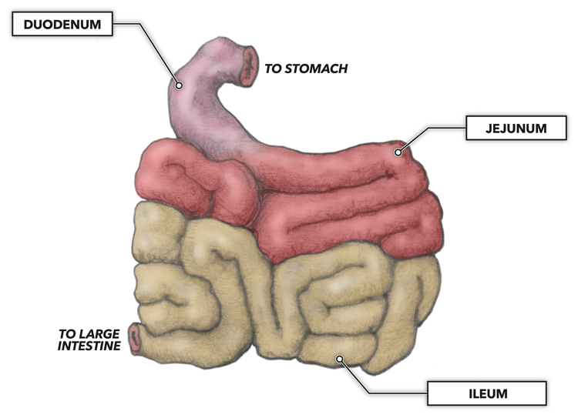 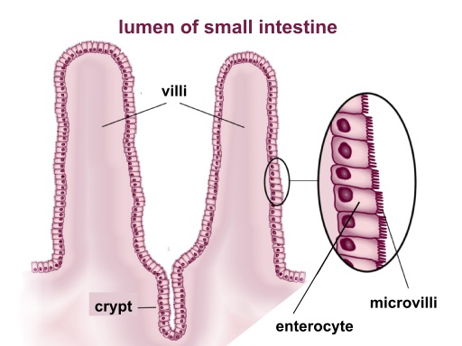

<https://pediaa.com/what-is-the-difference-between-villi-and-microvilli/> & <https://www.crossfit.com/essentials/the-gastrointestinal-system-small-intestine>

### Absorption

At this digestion is complete, the complex carbohydrate will have broken down into simple sugars and glucose, the proteins into amino acids, and the fat into fatty acids and glycerol. The inner lining of the small intestine, the mucosa, is covered in small finger-like projections called villi that extend from folded surface of the small intestine, increasing the surface area for absorption. The cells on the villi also contain projections, called microvilli.

The nutrients are absorbed into the bloodstream via the villi and microvilli of the small intestine. Fatty acids, glycerol, and water are absorbed by simple diffusion, and the glucose and amino acids are absorbed via active transport via the cells on the outside of the villi. All the nutrients pass into capillaries and enter the bloodstream to be distributed within the body. Any substances that are not absorbed in the small intestine pass into the large intestine. The chyme will spend an average of 2-6 hours in the small intestine.

## Nutrients uses

The nutrients released from the digestion of white bread are absorbed into the body to perform different functions. Glucose is the most abundant product of white bread digestion and is the main source of energy for the body, this energy is released through metabolic processes. Amino acids are used in the body for protein synthesis, which play many vital roles in the body for repair and growth. Fatty acids which are made once more into fats, are the body’s secondary source of energy after glucose.

## Large intestine

The left-over material from the small intestine enters the large intestine, where some minerals and vitamins, and the remaining water from the chyme are absorbed, turning it into a more solid substance called faeces. The bacterium in the large intestine breaks down any remaining starches releasing, vitamins (notably vitamin K) and minerals, which will all be absorbed into the bloodstream through the large intestine walls. The bacteria, called commensal bacteria does this through the process of fermentation whose by-product is the gases that exit the large intestine as wind.

Consequently, commensal bacteria has the function of preventing infections and pathogen attacks as the large intestine produces antibodies to combat commensal bacteria which in turn keeps us safe from potentially dangerous pathogens in the waste material. The waste material will spend about 15 – 59 hours, averaging 36 hours for most foods, in the large intestine before being expelled from the body.

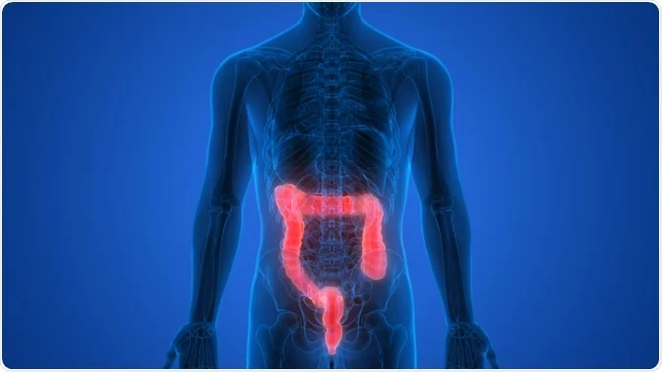

<https://www.news-medical.net/health/What-Does-the-Large-Intestine-Do.aspx>

## Elimination and faeces

The large intestine sends the compacted waste material to the rectum as faeces. The rectum is the end most part of the large intestine where the faeces is stored for elimination via the anus; the external opening at the end of the rectum. Faeces is made of unabsorbed water, undigested food material, bacteria, left over bile components and cellular material.

# Bibliography

Annigan, J. (2019). *White Bread and Digestion*. Retrieved from Livestrong.com: https://www.livestrong.com/article/520003-white-bread-and-digestion/

Garone, S. (2022, January 13). *How Starch Makes Its Way Through Your Body*. Retrieved from Livestrong.com: https://www.livestrong.com/article/488214-starch-and-digestion/

Newton, T. (2020). *Human Perspectives.* Melbourne: Cengage Learning Australia.

Radhakrishnan, R. (2020, November 12). *What Do Amino Acids Do?* . Retrieved from MedicineNet: https://www.medicinenet.com/what_do_amino_acids_do/article.htm

UPMC. (2022). *Difference Between Small and Large Intestine* . Retrieved from UMPC: https://www.chp.edu/our-services/transplant/intestine/education/about-small-large-intestines